1971
2 HCOONa + H₂SO₄ → 2 CO + 2 H₂O + Na₂SO₄
A 0.964 gram sample of a mixture of sodium formate and sodium chloride is analyzed by adding sulfuric acid. The equation for the reaction for sodium formate with sulfuric acid is shown above. The carbon monoxide formed measures 242 milliliters when collected over water at 752 torr and 22.0°C. Calculate the percentage of sodium formate in the original mixture.
Answer
P_{CO} = P_{atm} - P_{H2O} = (752 - 19.8) torr = 732.2 torr
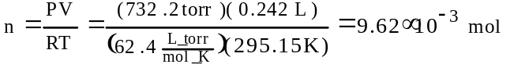
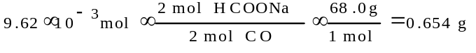
0.654 g/0.964 g × 100 = 67.9%

1971 B
At 20°C the vapor pressure of benzene is 75 torr, and the vapor pressure of toluene is 22 torr. Solutions in both parts of this question are to be considered ideal.
(a) A solution is prepared from 1.0 mole of biphenyl, a nonvolatile solute, and 49.0 moles of benzene. Calculate the vapor pressure of the solution at 20°C.
(b) A second solution is prepared from 3.0 moles of toluene and 1.0 mole of benzene. Determine the vapor pressure of this solution and the mole fraction of benzene in the vapor.
Answer:
(a) P_{C6H6} = χP°_{C6H6} = (⁴⁹/₅₀)(75 torr) = 73.5 torr
(b) P_{T} = χP°_{tol.} + χP°_{benz.}
= (³/₄)(22 torr) + (¹/₄)(75 torr) = 35.3 torr.
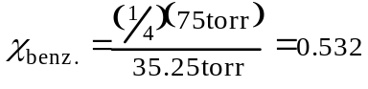

1972
A 5.00 gram sample of a dry mixture of potassium hydroxide, potassium carbonate, and potassium chloride is reacted with 0.100 liter of 2.0 molar HCl solution.
(a) A 249 milliliter sample of dry CO₂ gas, measured at 22°C and 740 torr, is obtained from the reaction. What is the percentage of potassium carbonate in the mixture?
(b) The excess HCl is found by titration to be chemically equivalent to 86.6 milliliters of 1.50 molar NaOH. Calculate the percentages of potassium hydroxide and of potassium chloride in the original mixture.
Answer:
(a)
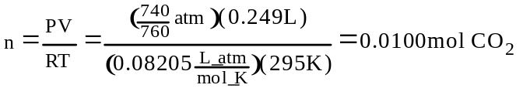
K₂CO₃ + 2 HCl → 2 KCl + CO₂ + H₂O
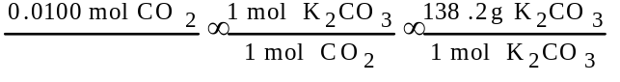
= 1.38 g K₂CO₃
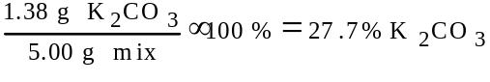
(b) KOH + HCl → K⁺ + Cl⁻ + H₂O
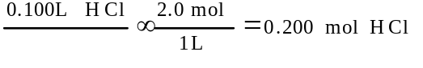
2(0.0100 mol) = 0.0200 mol HCl reacted with K₂CO₃
1 mol NaOH = 1 mol HCl
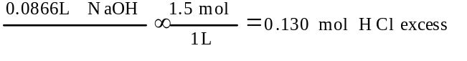
mol HCl reacted = (0.200 - 0.0200 - 0.130)mol = 0.050 mol
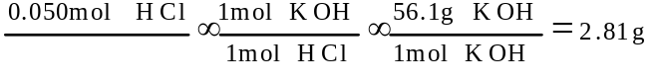
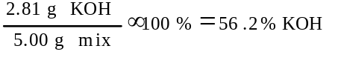
KCl = (100 - 27.7 - 56.2)% = 16.1% KCl

1973 B
A 6.19 gram sample of PCl₅ is placed in an evacuated 2.00 liter flask and is completely vaporized at 252°C.
(a) Calculate the pressure ion the flask if no chemical reaction were to occur.
(b) Actually at 252°C the PCl₅ is partially dissociated according to the following equation:
PCl₅(g) ↔ PCl₃(g) + Cl₂(g)
The observed pressure is found to be 1.00 atmosphere. In view of this observation, calculate the partial pressure of PCl₅ and PCl₃ in the flask at 252°C.
Answer
(a) 6.19 g PCl₅ / 208.22 g/mol = 0.0297 mol PCl₅
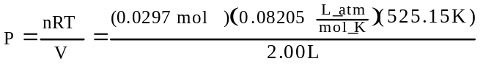
= 0.640 atm = 487 mm Hg
(b) P_{PCl3} = P_{Cl2} = X; P_{PCl5} = (0.640 - X) mm Hg
P_{T} = 1.00 atm = (0.640 - X) + X + X
X= 0.360 atm = P_{PCl3} = P_{Cl2}
P_{PCl5} = (0.640-0.360) atm = 0.290 atm = 220 mm

1976 D
When the molecular weight of a volatile liquid is calculated from the weight, volume, temperature, and pressure of a sample of that liquid when vaporized, the assumption is usually made that the gas behaves ideally. In fact at a temperature not far above the boiling point of the liquid, the gas is not ideal. Explain how this would affect the results of the molecular weight determination.
Answer:
Useful realtionship is: M= (gRT)/(PV). Significant intermolecular attraction exists at temperatures not far above boiling point.
Therefore, the compressibility of the gas is greater and the value of PV is smaller than predicted.
This would lead to a higher value for the molecular weight than the true value.

1982 D
(a) From the standpoint of the kinetic-molecular theory, discuss briefly the properties of gas molecules that cause deviations from ideal behavior.
(b) At 25°C and 1 atmosphere pressure, which of the following gases shows the greatest deviation from ideal behavior? Give two reasons for your choice.
CH₄ SO₂ O₂ H₂
(c) Real gases approach ideality at low pressure, high temperature, or both. Explain these observations.
Answer:
(a) Real molecules exhibit finite volumes, thus excluding some volume from compression.
Real molecules exhibit attractive forces, thus leading to fewer collisions with the walls and a lower pressure.
(b) SO₂ is the least ideal gas.
It has the largest size or volume.
It has the strongest attractive forces (van der Waals forces or dipole-dipole interactions).
(c) High temperature result in high kinetic energies.
This energy overcomes the attractive forces.
Low pressure increases the distance between molecules. (So molecules comprise a small part of the volume or attractive forces are small.)

1984 C
The van der Waals equation of state for one mole of a real gas is as follows:
(P + ª/_{V}2)(V - b) = RT
For any given gas, the values of the constants a and b can be determined experimentally. Indicate which physical properties of a molecule determine the magnitudes of the constants a and b. Which of the two molecules, H₂ or H₂S, has the higher value for a and which has the higher value for b? Explain.
One of the van der Waals constants can be correlated with the boiling point of a substance. Specify which constant and how it is related to the boiling point.
Answer:
“a” indicates intermolecular attractive force(s) in real gases.
“b” indicates actual volume of real molecules.
H₂S would have a larger “a” because it is a dipole and has stronger IMF. It would have a larger “b” because it is a larger molecule.
“a” is correlated with the boiling point. The larger the value the stronger the IMF and the higher the boiling point.

1986 B
Three volatile compounds X, Y, and Z each contain element Q. The percent by weight of element Q in each compound was determined. Some of the data obtained are given below.
Compound | Percent by Weight of Element Q | Molecular Weight
X | 64.8% | ?
Y | 73.0% | 104.
Z | 59.3% | 64.0
(a) The vapor density of compound X at 27 degrees Celsius and 750. mm Hg was determined to be 3.53 grams per liter. Calculate the molecular weight of compound X.
(b) Determine the mass of element Q contained in 1.00 mole of each of the three compounds.
(c) Calculate the most probable value of the atomic weight of element Q.
(d) Compound Z contains carbon, hydrogen, and element Q. When 1.00 gram of compound Z is oxidized and all of the carbon and hydrogen are converted to oxides, 1.37 grams of CO₂ and 0.281 gram of water are produced. Determine the most probable molecular formula.
Answer:
(a) 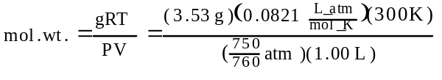
= 88.1 ^{g}/_{mol}
(b) X Y Z
88.1 g/mol 104 64.0
% Q 64.8 73.0 59.3
g Q 57.1 75.9 38.0
(c) ratio 1.5 2 1
masses must be integral multiples of atomic weight
therefore, 3 4 2
which gives an atomic weight of Q = 19
(d) 1.37 g CO₂ 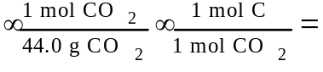
= 0.0311 mol C
0.281 g H₂O 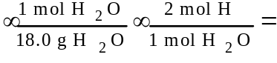
0.0312 mol H
1.00 g Z is 59.3% Q = 0.593 g Q
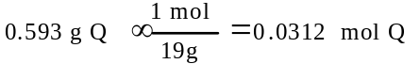
therefore, the empirical formula = CHQ, the smallest whole number ratio of moles.
formula wt. of CHQ = 32.0, if mol. wt. Z = 64 then the formula of Z = (CHQ)₂ or C₂H₂Q₂

1986 D
Give a scientific explanation for each of the following observations. Use equations or diagrams if they seem relevant.
(c) A hot-air balloon must be larger than a helium-filled balloon in order to lift the same weight.
Answer:
(c) Hot air is more dense than helium. OR Hot air has much less lifting power per unit volume than helium has.
A scientific explanation of the volume/lift relation.

1990 B
A mixture of H₂(g), O₂(g), and 2 millilitres of H₂O(l) is present in a 0.500 litre rigid container at 25°C. The number of moles of H₂ and the number of moles of O₂ are equal. The total pressure is 1,146 millimetres mercury. (The equilibrium vapor pressure of pure water at 25°C is 24 millimetres mercury.)
The mixture is sparked, and H₂ and O₂ react until one reactant is completely consumed.
(a) Identify the reactant remaining and calculate the number of moles of the reactant remaining.
(b) Calculate the total pressure in the container at the conclusion of the reaction if the final temperature is 90°C. (The equilibrium vapor pressure of water at 90°C is 526 millimetres mercury.)
(c) Calculate the number of moles of water present as vapor in the container at 90°C.
Answer:
(a) 2 H₂ + O₂ → 2 H₂O
mol H₂ = mol O₂ initially, but 2 mole H₂ react for every 1 mol of O₂, therefore, O₂ is left.
P_{T} = P_{H2} + P_{O2} + P_{H2O}
1146 mm Hg = P_{H2} + P_{O2} + 24 mm Hg
P_{H2} + P_{O2} = 1122 mm Hg
1122 mm Hg / 4 = P_{O2} left (¹/₂ of initial P_{O2} which is ¹/₂ total)
P_{O2} = 280.5 mm Hg
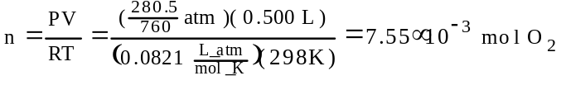
(b) 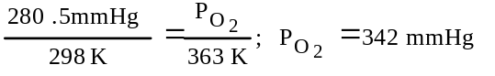
P_{T} = P_{O2} + P_{H2O} = (342 + 526)mm Hg = 868 mm Hg
(c) 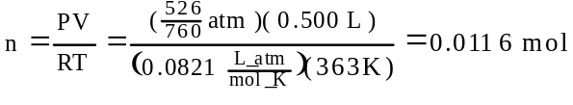

1993 D
Observations about real gases can be explained at the molecular level according to the kinetic molecular theory of gases and ideas about intermolecular forces. Explain how each of the following observations can be interpreted according to these concepts, including how the observation supports the correctness of these theories.
(a) When a gas-filled balloon is cooled, it shrinks in volume; this occurs no matter what gas is originally placed in the balloon.
(b) When the balloon described in (a) is cooled further, the volume does not become zero; rather, the gas becomes a liquid or solid.
(c) When NH₃ gas is introduced at one end of a long tube while HCl gas is introduced simultaneously at the other end, a ring of white ammonium chloride is observed to form in the tube after a few minutes. This ring is closer to the HCl end of the tube than the NH₃ end.
(d) A flag waves in the wind.
Answer:
(a) Reducing the temperature of a gas reduces the average kinetic energy (or velocity) of the gas molecules. This would reduce the number (or frequency) of collisions of gas molecules with the surface of the balloon; [OR decrease the momentum change that occurs when the gas molecules strike the balloon surface]. In order to maintain a constant pressure vs the external pressure, the volume must decrease.
(b) The molecules of the gas do have volume, when they are cooled sufficiently, the forces of attraction that exist between them cause them to liquefy or solidify.
(c) The molecules of gas are in constant motion so the HCl and NH₃ diffuse along the tube. Where they meet, NH₄Cl(s) is formed. Since HCl has a higher molar mass, its velocity (average) is lower, therefore, it doesn’t diffuse as fast as the NH₃.
(d) The wind is moving molecules of air that are going mostly in one direction. Upon encountering a flag, they transfer some of their energy (momentum) to it and cause it to move (flap!).

1994 B
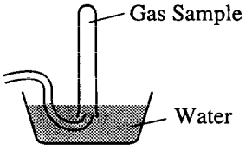
A student collected a sample of hydrogen gas by the displacement of water as shown by the diagram above. The relevant data are given in the following table.
GAS SAMPLE DATA
Volume of sample | 90.0 mL
Temperature | 25°C
Atmospheric Pressure | 745 mm Hg
Equilibrium Vapor Pressure of H₂O (25°C) | 23.8 mm Hg
(a) Calculate the number of moles of hydrogen gas collected.
(b) Calculate the number of molecules of water vapor in the sample of gas.
(c) Calculate the ratio of the average speed of the hydrogen molecules to the average speed of the water vapor molecules in the sample.
(d) Which of the two gases, H₂ or H₂O, deviates more from ideal behavior? Explain your answer.
Answer:
(a) P_{H2} = P_{atm} - P_{H2O} = (745 - 23.8) mm Hg
= 721.2 mm Hg
n = (PV)/(RT) = (721.2 mm Hg × 90.0 mL)/(62400 mm Hg.mL/mol.K × 298.15K)
= 3.49×10⁻³ mol
(b) n_{H2O} = (23.8 mm Hg × 90.0 mL)/(62400 mm Hg.mL/mol.K × 298.15K) × 6.022×10²³ molecules/mol = 6.93×10¹⁹ molecules
(c) (mass_{H2})(velocity_{H2})² = (mass_{H2O})(velocity_{H2O})²
2(v_{H2})² = 18(v_{H2O})²
v²_{H2}/ v²_{H2O} = 9; v_{H2}/ v_{H2O} = 3
(d) H₂O deviates more from ideal behavior:
(i) greater number of electrons = greater van der Waal attration
(ii) it is a polar molecule with strong polar attration
(iii) it hydrogen bonds to other water molecules
(iv) larger molecule and is slower at a given temp. and occupies more space.

1995 B (repeated in thermochem section)
Propane, C₃H₈, is a hydrocarbon that is commonly used as fuel for cooking.
(a) Write a balanced equation for the complete combustion of propane gas, which yields CO₂(g) and H₂O(l).
(b) Calculate the volume of air at 30°C and 1.00 atmosphere that is needed to burn completely 10.0 grams of propane. Assume that air is 21.0 percent O₂ by volume.
(c) The heat of combustion of propane is -2,220.1 kJ/mol. Calculate the heat of formation, ΔH°_{f}, of propane given that ΔH°_{f} of H₂O(l) = -285.3 kJ/mol and ΔH°_{f} of CO₂(g) = -393.5 kJ/mol.
(d) Assuming that all of the heat evolved in burning 30.0 grams of propane is transferred to 8.00 kilograms of water (specific heat = 4.18 J/g.K), calculate the increase in temperature of water.
Answer:
(a) C₃H₈ + 5 O₂ → 3 CO₂ + 4 H₂O
(b) 10.0 g C₃H₈ × 1 mol C₃H₈/44.0 g × 5 mol O₂/1 mol C₃H₈) = 1.14 mol O₂
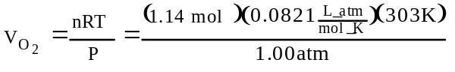
= 28.3 L O₂ ; 28.3 L/21.0% = 135 L of air
(c) 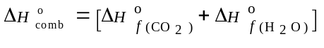
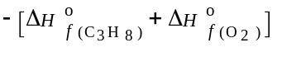
-2220.1 = [3(-393.5) + 4(-285.3)] - [X+ 0]
X = ΔH°_{comb} = -101.7 kJ/mol
(d) q = 30.0 g C₃H₈ × 1 mol/44.0 g × 2220.1 kJ/1 mol = 1514 kJ
q = (m)(C_{p})(ΔT)
1514 kJ = (8.00 kg)(4.18 J/g.K)( ΔT)
ΔT = 45.3°

1996 D (Required)
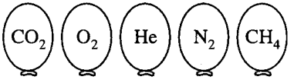

Represented above are five identical balloons, each filled to the same volume at 25°C and 1.0 atmosphere pressure with the pure gases indicated.
(a) Which balloon contains the greatest mass of gas? Explain.
(b) Compare the average kinetic energies of the gas molecules in the balloons. Explain.
(c) Which balloon contains the gas that would be expected to deviate most from the behavior of an ideal gas? Explain.
(d) Twelve hours after being filled, all the balloons have decreased in size. Predict which balloon will be the smallest. Explain your reasoning.
Answer:
(a) CO₂; according to Avogadro’s Hypothesis, they all contain the same number of particles, therefore, the heaviest molecule, CO₂ (molar mass = 44), will have the greatest mass.
(b) all the same; at the same temperature all gases have the same kinetic energy.
(c) CO₂; since they are all essentially non-polar, the largest intermolecular (London) force would be greatest in the molecule/atom with the largest number of electrons.
(d) He; it has the smallest size and has the greatest particulate speed and, therefore, it’s the easiest to penetrate the wall and effuse.

